

MASENO 2025 KCSE PREDICTION
CONFIDENTIAL EXAM
312/2
GEOGRAPHY
PAPER 2
TIME: 2¾ HOURS

NAME……………………………………………………………………………………….
SCHOOL……………………………………………… SIGN………………………..
INDEX NO……………………………………………. ADM NO……………………

(Kenya Certificate of Secondary Education)

Instructions to the candidates
- Write your name and index number in the spaces provided above
- Sign and write the date of examination in the spaces provided above
- This paper consists of two sections; A and B
- Answer ALL questions in section A.
- Answer question 6 and any other two questions from section B
- Answers MUST be written in the spaces provided at the end of question 10

FOR EXAMINER’S USE ONLY
SECTION | QUESTION | MAXIMUM SCORE | CANDIDATE’S SCORE
A | 1 - 5 | 25
B | 6 | 25
 |  | 25
 |  | 25
TOTAL SCORE

SECTION A
Answer All the questions in this section
- a). Define the term Forestry (2marks)
b). Give the reason why softwood forests in the Kenya Highlands mature faster than those in Canada. (2marks)
c). Name the tree species that grows on the saline coastal waters (1mark)
- a). Identify two methods that are used to drain swamps in Kenya (2marks)
b). Give three benefits of draining Yala swamp to the local community (3marks)
- a). Define the term green energy (2marks)
b). Name three sources of Green Energy (3marks)
- a). Name two rivers in Africa, that are navigable (2marks)
b). State three factors that have hindered river transport in Africa (3marks)
- a). Name two deciduous fruits grown in Kenya (1mark)
b). State three reasons why horticulture farming is concentrate near Naivasha (3marks)

SECTION B
Answer question 6 and two other questions from this section
- Use the following table to answer questions 6(a) (i) and (ii)
Number of dairy animals in division x in the Kenyan highlands in 1982
BREED | NUMBER
Gursey | 8442
Ayshire | 7345
Jersey | 10,830
Fresian | 14,360
Sahiwal | 4,270
a). (i) Using a scale of 1cm to represent 4000 animals represent the above data using a simple divided rectangle (8marks)
(ii). Give three advantages of using divided rectangles to represent data (3marks)
(iii). State three advantages of using artificial insemination in cattle breeding (3marks)
b). Give three characteristics of each of the following types of farming.
(i) Subsistence farming (3marks)
(ii) Extensive farming (3marks)
c). State five human factors that favour beef farming in Argentina (5marks)

7.(a) (i) Differentiate the term veins from Lodes in mining (2marks)
(ii) State the reason why mining is called a Robber Industry (2marks)
(b) (i) Fill in the table below on Kenyan minerals(in your answer booklet)
Mineral | Where mined | Mining method used
God
Limestone
Petroleum/ Oil

(2marks)
(2marks)

(2marks)
(ii) Describe how Trona is mined in Lake Magadi (4marks)
(iii) State four ways in which Trona mining has promoted the growth of Magadi Town in Turkana County
(c).(i) Name two provinces in South Africa where Gold is mined (2marks)
(ii) State five problems facing Gold mining in South Africa (5marks)

8. (a). Use the map of North America below to answer question (a)(i) and (ii)
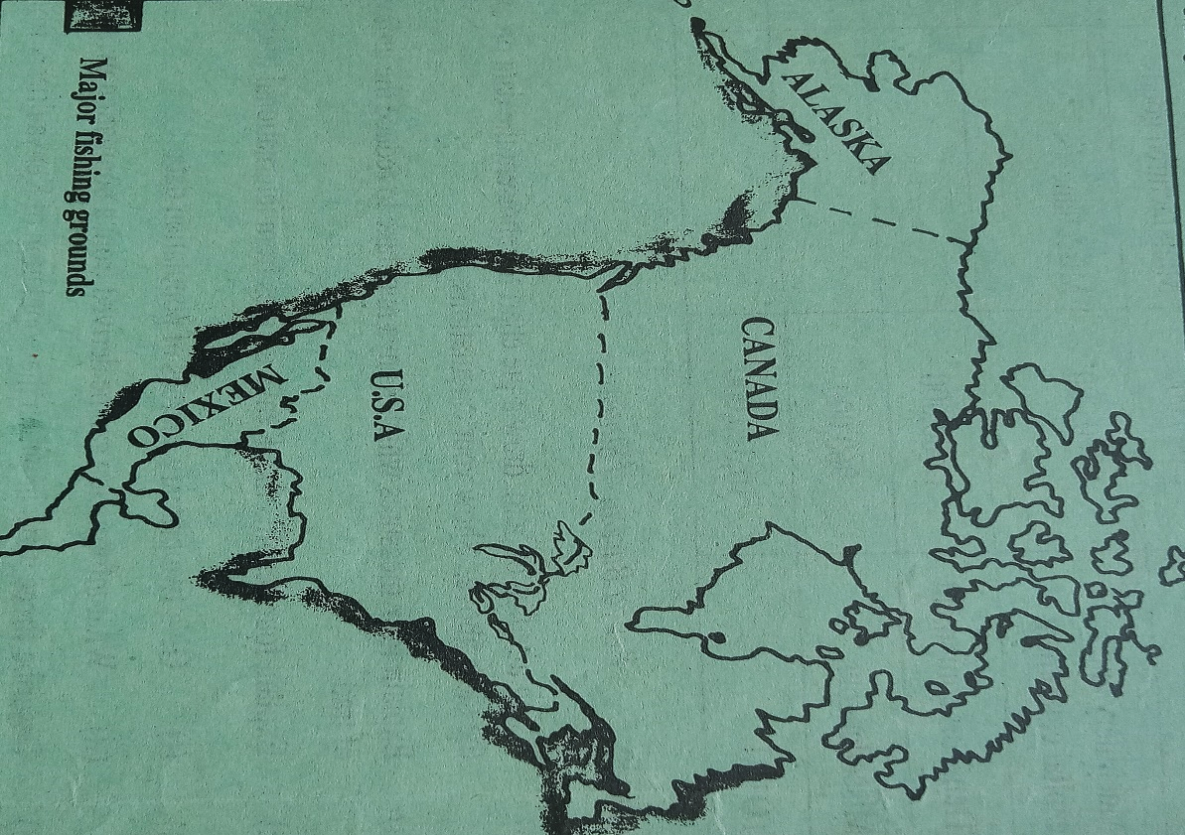

- Name the fishing grounds marked M and N (2marks)
- From the map identify the physical factor favouring fishing in the two named grounds
(1mark)
- State three measures taken to conserve the Salmon fish in the fishing ground mark M from depletion (3marks)
(b).(i). Name three main fish landing beaches on Kenya’s Lake Victoria (3marks)
(ii). Explain four factors favouring fishing in Lake Victoria (8marks)
(c). (i). What is fish farming (2marks)
(ii). Apart from the Tilapia, name two main types of fish reared in fish farms in Kenya (2marks)
(iii). State four reasons why Tilapia is more popular in fish farming in East Africa (4marks)

9. (a)(i) Distinguish between balance of trade and balance of payment (2marks)
(ii). If Kenya imported electronics and automobiles worth Ksh. Ksh. 200,002,987/=, medical services worth Ksh. 185,876,440/= in the year 2000, while their exports the same year were agriculture, Ksh. 189,000,657/= and education Ksh. 150,012,230/=. Calculate Kenya’s balance of trade in that year. (2marks)
(b). (i). List three major exports from Kenya to the European Union (3marks)
(ii). Give four reasons why Southern African Development Co-operation (SADC) was formed.
(4marks)
(c).(i). Explain the following trade restrictions terms
- Tarifs (2marks)
- Quotas (2marks)
- Trade agreements (2marks)
- Total bans (2marks)

(ii). Explain three factors which negatively impact on Kenya’s International trade (6marks)

10.(a)(i). Identify the statistical diagram below (1mark)
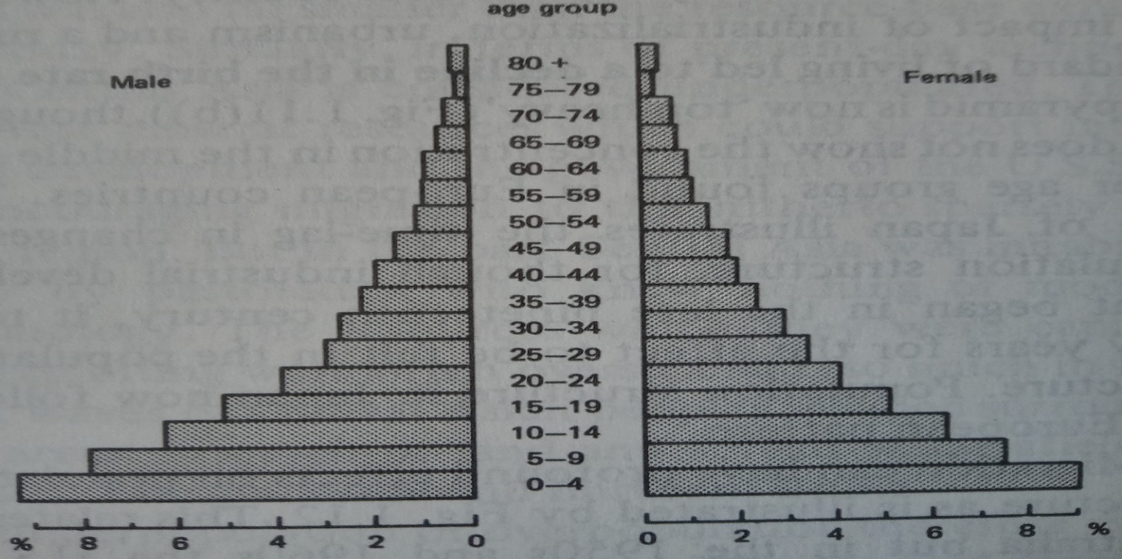

(ii). Name three types of information that may be derived from the above statistical diagram (3marks)
(iii). Give three factors that influence population growth (3marks)
(b).(i). Explain four possible reasons for the sudden rise of population in North Eastern Kenya (8marks)
(ii). State three negative effects of a high population growth on the natural environment (3marks)
(c). (i). Name three other types of internal migration other than Rural to urban (3marks)
(ii). State five measures taken by the Government to curb rural to urban migration (4marks)

THIS IS THE LAST PRINTED PAGE

